|  |  |
| --- | --- |
| cetlogo ***CHEMICAL ENGINEERING TRANSACTIONS***  ***VOL.*** | A publication of  aidiclogo_grande |
| The Italian Association  of Chemical Engineering  Online at www.cetjournal.it |
| Guest Editors:  Copyright © AIDIC Servizi S.r.l. **ISBN** 978-88-95608-xx-x **ISSN** 2283-9216 | |

Application of an Advanced System for the Monitoring of WWTP Odour Emissions and Benefits of its Use

Daniel Almarchaa, Manuel Almarchaa, Martí de Riquerb, Raul Arasab, Jesica Piñonb, Marta Aleixandrec, Enrique Baquerizod

aAtmos-Tek. Rosselló 64, 7-1, 08029 Barcelona, Spain.

bMeteosim. Baldiri Reixac 10-12, 08028 Barcelona, Spain.

cSociedad de Fomento Agrícola Castellonense S.A. (FACSA), Calle Mayor, 82-84, 12001 Castelló de la Plana, Spain.

dEmpresa Municipal de Aguas de Sevilla S.A. (EMASESA) Calle Escuelas Pías, 1, 41003 Sevilla, Spain.

dalmarcha@chempharma-env.com

The odoriferous profile of WWTP emissions is typically associated with the presence of Volatile Sulphur Compounds (VSC), such as H2S, mercaptans and thioethers. There are different systems for continuous monitoring of odour in ambient air and / or emission (such as H2S detectors and electronic noses). These systems are typically based on low-cost sensors that do not allow the main odorants to be determined reliably at low enough levels such as those typically present in immission. As an alternative, it has been proposed to use the Vigi eNose® system (Chromatotec, Fr.), which can be applied both in emission and immission situations. This equipment consists of a gas chromatograph with a selective S detector (capable of sequentially measuring up to 14 individual VSCs in different points with a wide dynamic range and with a Limit of Detection, LD, between 0.5 and 8 ppbv). This system is supplemented with a Photoionization Detector (PID) that provides values assimilable to total VOC concentrations.

This system has been installed in the San Jerónimo WWTP (Seville, Spain), where 5 emission sources have been monitored, plus one immission point. The data generated by the Vigi eNose® are modelled in near real time and in forecast mode on the Meteosim online platform (Meteosim Solution®) using CALPUFF.

This paper presents data obtained over a month of monitoring, as well as the results of 3 sampling and analysis campaigns carried out in order to verify the applicability of the system. Monitoring data and campaign results showed a positive correlation between the different analytical techniques used.

* 1. Introduction

Emissions from wastewater treatment plants (WWTP) contain substances with different odoriferous significance (Anneli et al., 2006). The main families of substances are Volatile Sulphur Compounds (VSC) such as H2S, mercaptans, and thioethers, free fatty acids (FAV), such as butanoic acid, pentanoic acid, nitrogen compounds such as amines or indole derivatives and carbonyls (aldehydes and ketones).

VSC compounds are the largest contributors to WWTP odour emissions due to their frequency, levels and low olfactory threshold (typically of few ppb or even at sub-ppb level) and of their Odour Activity Values (OAV) (Capelli et al., 2008). Therefore, they are the group of target compounds that are typically taken as a reference to characterise WWTP odorants and to assess odour impacts on immission. In some cases, VSC compounds can be used to set limits based on the concentrations of H2S, mercaptans or thioethers. However, the characteristics of the operations and processes carried out at the different parts of the plants, the diurnal and weekly cycles, the weather and the time of the year (Jeon et al, 2009) can significantly impact on the qualitative and quantitative composition of the VSC from the WWTP.

The different procedures to characterise odour emissions and their impact present a series of limitations that do not allow their use in a single universal way (Muñoz et al., 2010; Bax et al. 2020; Hashisho et al., 2012) and require adjustments for low chemical concentrations in each case. Limited sensitivity is common among these methodologies. Low odour concentrations in ambient air cannot be measured by dynamic olfactometry, as the typical LOD limit of the technique is in the range of 15 ouE/m3. Moreover, low chemical concentration measurements cannot be achieved by single-analyte low-cost sensors, which usually have LODs for H2S measurement ≥10 ppbv, when H2S can already cause odour nuisances even at lower concentrations due to its low Odour Threshold (OT), which, according to E. Nagata (2003) and J.H. Ruth (1986), is lower than 15 g/m3. Other possible problems with these methods include: poor specificity, high uncertainties, complicated calibration procedures, significant influence of environmental conditions (such as humidity or temperature), …

Table 1 presents the optimal characteristics that an analyser should have in order to be used in the continuous characterization of WWTP odoriferous emissions or, alternatively, for the determination of VSC-type odorants in ambient air at concentrations of the same order as their OTs or lower (J.P. Amiet et al, 2014). These characteristics are compared with those of a Vigi e-Nose® system, which meets all the defined requirements, and it should be noted that it also complies with those outlined in Van Harreveld, 2012 for sensors suitable for use in emission or immission.

*Table 1: Optimal characteristics required of an emission and immission analysis system of the most significant odour pollutants from WWTP vs characteristics of the Vigi e-Nose*® *system*

|  |  |
| --- | --- |
| Optimal characteristics required for odour analysers in WWTPs | Characteristics of the Vigi e-Nose® system |
| Ability to determine the most significant odorants | Adaptable amount of VSC (up to 15 compounds/20min) |
| Possibility of sample pre-conditioning of in order to eliminate the influence of T and humidity on the results | Yes |
| "On-line" measurement (in continuous or semi-continuous mode) | Yes. Analysis time: 10 min for 8 VSC//20 min for up to 14 VSCs |
| Ability to manage analytical data and its transmission | Yes |
| Analytical specificity | Combining the HRGC with specific VSC and PID detectors. NH3 or FID detectors can also be included. |
| Select target VSC group according to each case | Yes |
| Sufficient sensitivity according to the concentration ranges close to the OT | LDL: 0.25-8 ppb. If (optionally) coupled with Thermal Desorption, limits can be reduced to 0,1 ppb |
| Sufficiently wide dynamic range (emission and immission) | Dynamic range: 0.25 ppb-10,000 ppb |
| Possibility for the same device to measure VSCs in emission and / or immission | Yes |
| Stability of response | RSD < 3 % on concentration over 48 h  RSD < 0.5 % on retention time over 48 h |
| Operational and response robustness | Yes. This is a process analyzer |
| Self-sufficiency regarding the use of consumables | Own carrier gas generator and automatic calibration system and permeation tubes standards. No H2 is used |
| Possibility of sequential analysis of samples from multiple (nearby) sources | Yes, up to 6 sources analyzed sequentially, combining emission and immission, if necessary |
| Ability to control the performance of atmospheric emission treatment systems | Yes, by sequentially measuring the inlet and outlet of the treatment system |

The Vigi eNose® analyser consists of a gas chromatograph with an electrochemical wet cell selective detector for the automatic analysis and monitoring of up to 14 individual VSC with LODs between 0.5 and 8 ppbv. The system is also provided with a photoionization detector (PID) to determine the total VOC concentration. The measurement results can be presented as individual concentrations of up to 14 VSC and as the sum of the OAV of the detected S derivatives (Sulphur Odour Index or S-OI), and VOCtot. In addition, it is possible to correlate these S-OI values with odour concentrations determined by dynamic olfactometry, as shown in Choi et al., 2012 and Li et al., 2017.

The equation used for the calculation of the S-OI value is:

|  |  |
| --- | --- |
| $$S-OI= \sum_{i=1}^{n}{\frac{{C(VSC)}_{i}}{{OT(VSC)}_{i}}}$$ | (1) |

Where S-OI is the Sulphur Odour Index, C(VSC)i are the concentrations of each of the different sulphur odorants analysed and OT(VSC)i are the odour thresholds of the sulphur odorants.

Furthermore, as the Vigi e-Nose® system is capable of performing a continuous characterization of multiple emission sources of different nature (point-source, aerial, volumetric, etc…), the measured concentrations can be easily and constantly sent to feed a cloud dispersion modelling system. Using a specific multi-source emission database, coupled to an online-dispersion model, can provide a relevant impact assessment capacity improvement, by providing, for example, a time-continuous pollutant dispersion and impact analysis (modelling results every 10 minutes) of a WWTP’s onsite measured emissions. Odour forecasting capabilities can be also implemented by coupling the dispersion model to a plant operation emission model (based on machine learning technology) and weather forecasting information systems.

3 sampling and analysis campaigns were carried out between November of 2021 and January of 2022, in order to assess the performance of the Vigi eNose® system. The scope of these campaigns is described in the following section.

* 1. Materials and Methods

3 sampling campaigns were carried out in the San Jerónimo WWTP in November of 2020, July of 2021 and January of 2022, respectively. The emission samples were taken from 10 sources (including the 6 sources connected to Vigi eNose® system for on-line monitoring) in 10 L Nalophan® bags using the necessary equipment as appropriate (lung device, Lindvall hood, probe, …). Concurrent temperature, humidity and velocity measurements were also made where applicable. The measured sources include: biofilter outlet treating headwork emissions, primary settler, primary settler’s carbon filter outlet, biological treatment, sludge digester carbon filter outlet, secondary settler, sludge scrubber outlet, cogeneration vent and stack, and sludge storage carbon filter outlet. Four replicates were taken of each sample: three were used exclusively for the odour concentration analysis and the fourth one was for the rest of the determinations, following the methodology indicated in Almarcha et al. (2014).

Odour concentration was measured in the emission samples by dynamic olfactometry and was performed by SGS Tecnos S.A., Spain. H2S concentration was analysed with the Vigi eNose® system working in manual mode and also with a Jerome J605 portable H2S analyser. VSC concentrations were analysed as well by means of the Vigi eNose® system, also in manual mode.

For the present assessment, the Meteosim Solution® software, an online combination of the WRF-ARW model (meteorology), Air Emission Model of Meteosim (emissions intelligent database), CALMET system (meteorological pre-processor) and CALPUFF model (dispersion), has been used to build the online dispersion and odour impact analysis tool for advanced and proactive management of WWTPs.

* 1. Results and discussion

Two different types of results will be presented in this section. Firstly, a summary of all the results obtained during 1 month (September-October 2021) of the Vigi eNose®’s normal operation. Secondly, a summary the results of the 3 sampling and analysis campaigns carried out are shown. For the analyser’s regular operation, 5 emission sources (the biofilter outlet, the sludge digester, the primary settler’s carbon filter outlet, the biologic treatment and the sludge scrubber) were sequentially aspirated and analysed in 20-minute cycles. The results of the analyses have been used to prepare the summary included in Table 2 and Figure 1, which show the average H2S and other VSC concentrations obtained with the Vigi eNose® system during this 1-month period.

Table 2: Average September-October 2021 Vigi eNose® results (ppbv) of VSC in 5 emission sources.

|  |  |  |  |  |  |  |  |  |  |  |
| --- | --- | --- | --- | --- | --- | --- | --- | --- | --- | --- |
| Source | H2S | 2-Butyl-SH | DES | DMDS | DMS | Ethyl-SH | Iso-Butyl-SH | MES | Methyl-SH | Odour Index |
| Biofilter outlet | 0.7 | 0.6 | 4.1 | 14.4 | 0.0 | 0.0 | 0.4 | 0.2 | 0.8 | 202 |
| Sludge digester | 2.7 | 0.2 | 6.7 | 5.8 | 1.6 | 0.2 | 0.8 | 0.2 | 13.2 | 357 |
| Prim. settler carbon filter | 4.0 | 0.3 | 25.5 | 683.4 | 10.0 | 0.0 | 0.3 | 0.5 | 36.4 | 2,500 |
| Biologic treatment | 1.2 | 0.8 | 1.5 | 32.4 | 42.7 | 0.0 | 0.5 | 0.4 | 2.6 | 4,554 |
| Sludge scrubber | 7.8 | 0.8 | 0.4 | 26.2 | 0.1 | 0.0 | 0.3 | 2.8 | 11.6 | 316 |

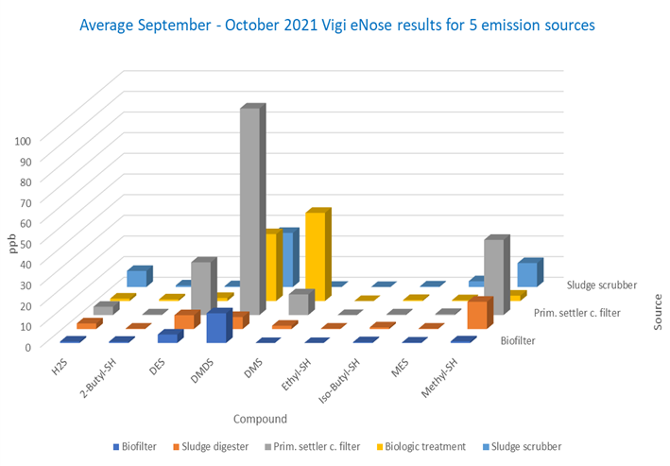

Figure 1: Average September-October 2021 Vigi eNose® analyses of VSC in 5 emission sources

Figure 2a shows a comparison between the average results of the Primary settler’s carbon filter. In the case of the biologic treatment, there is a significant agreement between the Methyl Mercaptan concentrations and the calculated S-OI values, which indicates that this may be the main odorant in this source. In the case of the Primary Settler’s carbon filter outlet, however, the results show that the odour emissions may be attributed to DMDS. Figure 2b is a comparison between the H2S and Methyl Mercaptan results of 2 days of Vigi eNose® analyses of the Primary settler’s carbon filter outlet and the Biological Reactor. While in the case of the primary settler carbon filter outlet both analytes follow the same trend, in the case of the Biological Reactor the H2S and Methyl Mercaptan concentrations present opposite behaviours.

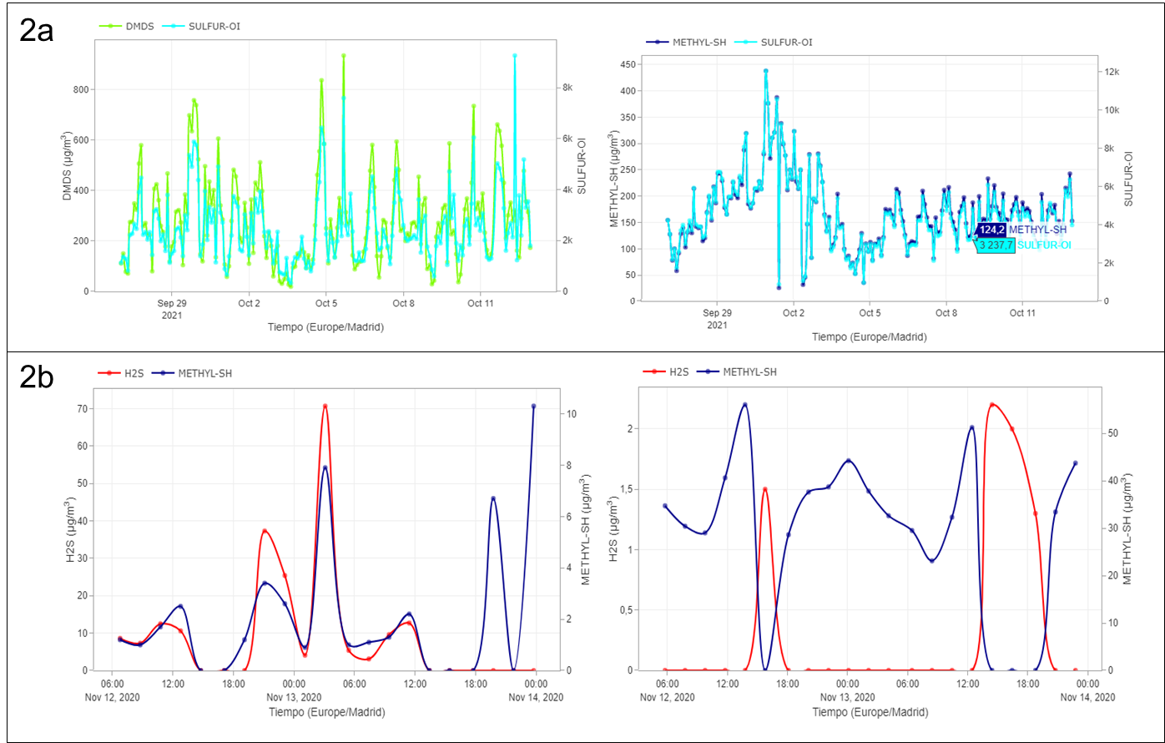

Figure 2a (Above): Comparison of average September-October 2021 Vigi eNose® results. Left: Primary settler carbon filter outlet, DMDS vs S-OI; Right: Biological reactor, Methyl-SH vs S-OI. Figure 2b (below) Comparison of 2 days of Vigi eNose® results for H2S (red) and Methyl-SH (blue). Left: Primary settler carbon filter outlet; Right: Biological Reactor.

A summary of the results obtained during the 3 campaigns that took place in 2020, 2021 and 2022, respectively, are presented next in Table 3, which shows a comparison between the emission results obtained with the Vigi eNose® system and the Jerome analyser. Duplicate samples were analysed for each source, and the average value is shown in the table. H2S and VSC Results (ppbv) were obtained by Vigi e-Nose® and Jerome Analyzer, and the Odour Concentration was determined Dynamic Olfactometry.

Table 3: Results of the analyses of 5 emission sources (ppbv). Average of 3 campaigns (2020-2022).

|  |  |  |  |  |
| --- | --- | --- | --- | --- |
| Source | H2S Vigi eNose® | H2S Jerome | S-OI | Odour Conc. (ouE/m3) |
| Biofilter outlet | 2.1 | 2.9 | 190 | 70 |
| Sludge digester carbon filter outlet | 2.3 | 8.5 | 277 | 218 |
| Prim. settler carbon filter outlet | 19.9 | 20.8 | 1,135 | 484 |
| Biological reactor | 0.0 | 5.8 | 743 | 366 |
| Sludge scrubber outlet | 35.6 | 35.9 | 1,756 | 1,413 |

The results obtained with the Vigi eNose® system and the other analytical methods similarly find that the H2S data indicated in Table 3, as well as in Figure 3, shows a significant correlation between the odour concentrations measured by dynamic olfactometry and the S-OI. This parameter is automatically obtained by a proprietary algorithm using the corresponding olfactory thresholds of the Vigi eNose® analyser.

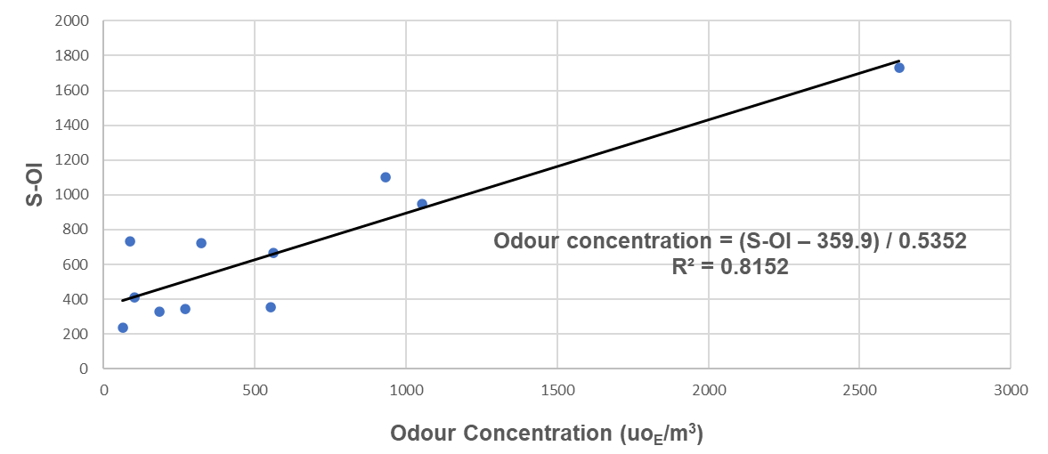

Figure 3: Correlation between calculated S-OI values and Odour concentrations obtained in the 3 campaigns

The following figure shows two example Vigi eNose® chromatograms corresponding to samples from the Biological Reactor and the Sludge Scrubber outlet, respectively.

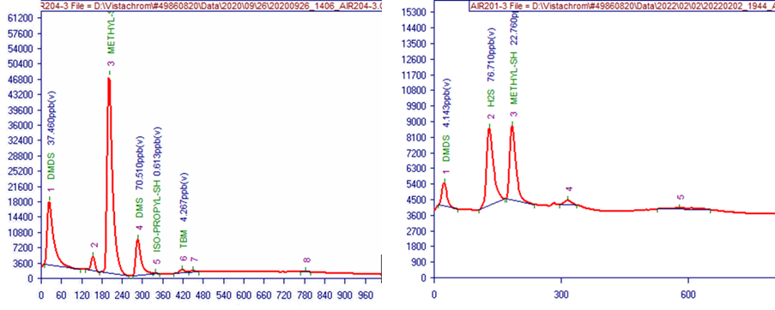

Figure 4: Examples of chromatograms obtained with the Vigi eNose® system corresponding to a sample from the Biological Reactor (left) and the Sludge Scrubber outlet (right).

* 1. Conclusions

Low cost H2S sensors, on one hand, do not sufficiently express the complexity of WWTP emissions with regards to odour and, on the other hand, as is also the case with e-Noses, they do not have sufficient sensitivity to determine H2S or the immission odour concentration at the location of the receptors at levels comparable to the required odour concentration limits. Furthermore, these types of sensors are generally not designed to perform continuous measurements on emission sources and, therefore, it is not possible to obtain immission results by means of online modelling.

The results show that the Vigi eNose® system is capable of high sensitivity sequential real-time monitoring of odour emissions from different sources at the San Jerónimo WWTP, and also of analysing immission samples at low-ppbv levels.

The results were found to be equivalent to those obtained by the other analytical methods that were applied throughout the 3 campaigns. Moreover, the performance of the system represents an improvement over that of other sensor solutions for sensitivity and chemical speciation of the odorants. This is particularly helpful in cases where the main odoriferous substances in the emissions are VSCs, such as WWTPs, landfills, rendering plants and other facilities.

It must be also pointed out that the data shows a significant correlation between the S-OI values calculated from the Vigi eNose® results and the odour concentrations determined by Dynamic Olfactometry.

References

Almarcha D., Almarcha M., Jiménez-Coloma E., Vidal L., Puigcercós M., Barrutiabengoa I., 2014, Treatment Efficiency by means of a Nonthermal Plasma Combined with Heterogeneous Catalysis of Odoriferous Volatile Organic Compounds Emissions from the Thermal Drying of Landfill Leachates, Journal of Engineering 2014 (6).

Amiet J.P., Vivola L., 2014, Continuous Monitoring of Odourous Compounds in Waste Water Treatment Plants - Sensory approach or Physico-chemical solution? Envirotech-online <envirotech-online.com/article/water-wastewater/9/chromatotec/continuous-monitoring-of-odourous-compounds-in-waste-water-treatment-plants-sensory-approach-or-physico-chemical-solution/1716> accessed 13.04.2022.

Anneli A. C., Hanæus J., 2006, Odorous Wastewater Emissions, Vatten, 62, 227–236.

Bax C., Sironi S., Capelli L., 2020, How Can Odors Be Measured? An Overview of Methods and Their Applications, Atmosphere, 11, 92.

Capelli L., Sironi S., Del Rosso R., Céntola P., Il Grande M., 2008, A comparative and critical evaluation odour assessment methods on a landfill site, Atmospheric Environment, 42, 7050-7058.

Choi H.L., Shin J., Kim H., 2012, Evaluation of the Effectiveness of Five Odor Reducing Agents for Sewer System Odors Using an Online Total Reduced Sulfur Analyzer, Sensors, 12, 16892-16906.

Hashisho Z., Small C.C., Morshed G., 2012, Review of Technologies for the Characterization and monitoring of VOCs, Reduced Sulphur Compounds and CH4.Oil Sands Research and Information Network, University of Alberta, School of Energy and the Environment, Edmonton, Alberta. OSRIN Report No. TR-19.

Jeon E., Son H., Sa J., 2009, Emission Characteristics and Factors of Selected Odorous Compounds at a Wastewater Treatment Plant, Sensors, 9, 311-326.

Kabir E., Kim K.H., Ahn J.W., Hong O.F., Chang Y.S., 2010, Offensive odorants released from stormwater catch basins (SCB) in an urban area, Chemosphere 81 327–338.

Li W., Yang W., Li J., 2017, Characterization and prediction of odours from municipal sewage treatment plant, Water Science & Technology, (3): 762–769.

Muñoz R., Sivret E.C., Parcsi G., Lebrero R., Wang X., Suffet I.H., Stuetz R.M., 2010, Monitoring techniques for odour abatement assessment, Water Research, 44, 5129-5149.

Nagata E., Yoshio Y., 2003, Measurement of Odor Threshold by Triangular Odor Bag, Japan Ministry of the Environment, Tokyo, pp. 118-127.

Ruth J.H., 1986, Odor thresholds and irritation levels of several chemical substances: a review, American Industrial Hygiene Association Journal, 47(3):A142-51.

Susaya J., Kim K.H., Phan N.T., Kim J.C., 2011, Assessment of reduced sulfur compounds in ambient air as malodor components in an urban area, Atmospheric Environment 45, 3381-3390.

Van Harreveld A.P., 2012, The need for continuous odour monitoring techniques in odour management and currently available technical solutions, Chemical Engineering Transactions, 30, pp. 37-42 Il.

Wu C., Liu J., Zhao P., Piringer M., Schauberger G., 2016, Determination of the Odour Concentration and Odour Intensity of a Mixture of Odorous Substances by Chemical Concentrations: a Comparison of Methods, Chemical Engineering Transactions, 54: 97-102.